**Choosing Colours**

I first chose my colours from Adobe Colour Picker.

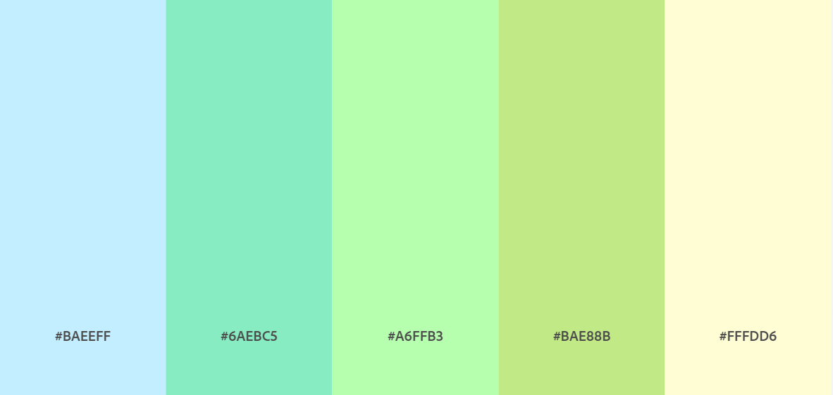

**Wireframe Layout**

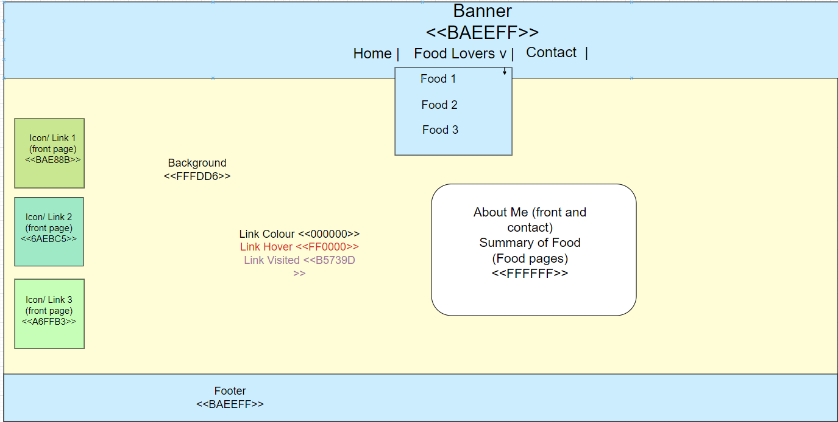

I then created a wireframe using these colours of my choice using draw.io. I created rectangles using the hexadecimal values on the palette listed above. The ‘v’ next to the heading ‘Food Lovers’ is an arrow, indicating that it is a dropdown menu which is shown by the rectangle below it. I added the colours of the text inside each section then took a snip and saved the final file.

**HTML Layout**

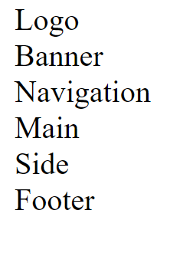

I created a big div called container, which is used to combine the following divs; logo, banner, navigation, main, sidebar and the footer to divide my website. I added text between each div then validated my html code.

**Validation of HTML Layout**

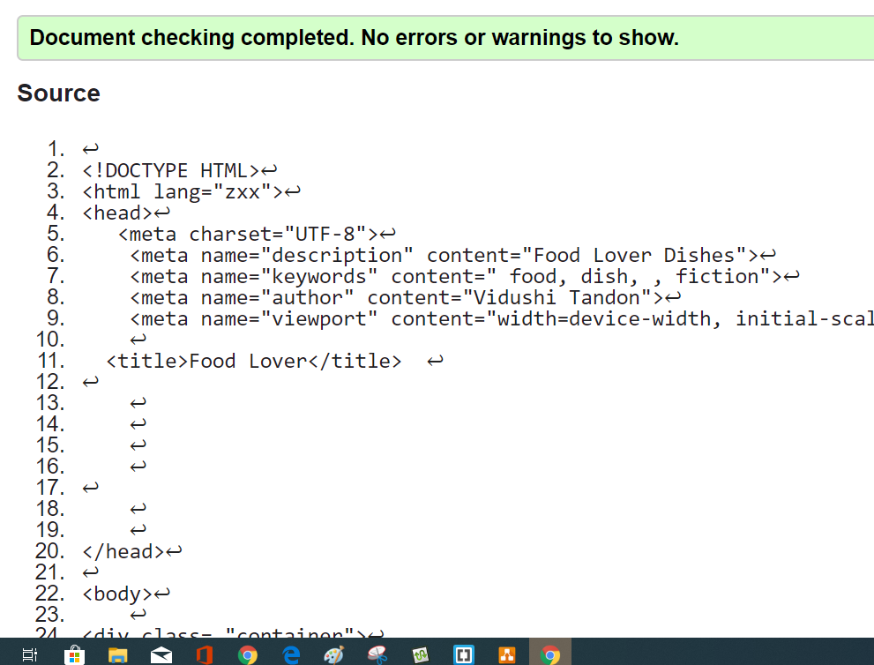

**Grid Layout**



I set up my CSS file with my container div, to divide the grid columns into 175px (pixels), 500px and 1fr or 1 fraction as I want room for those icons. I set in the body also margin set to auto, padding set to 30px and the colour to black. I then validated my CSS code.

**Validation of CSS Grid Layout**

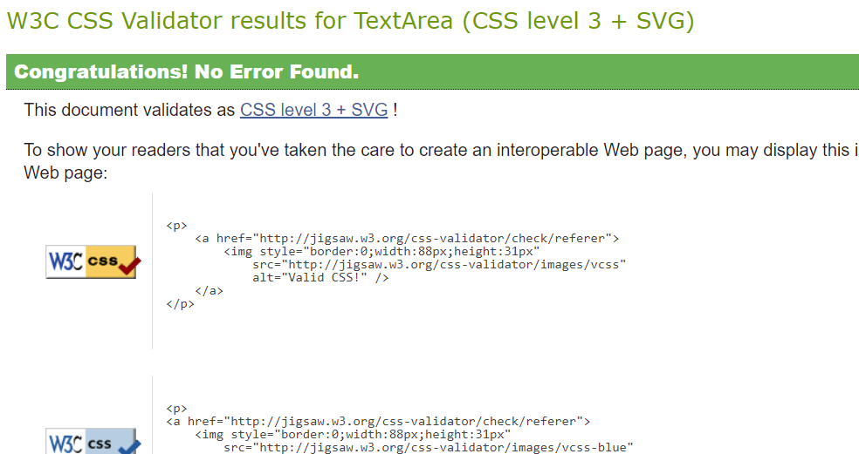

**Grid Area**

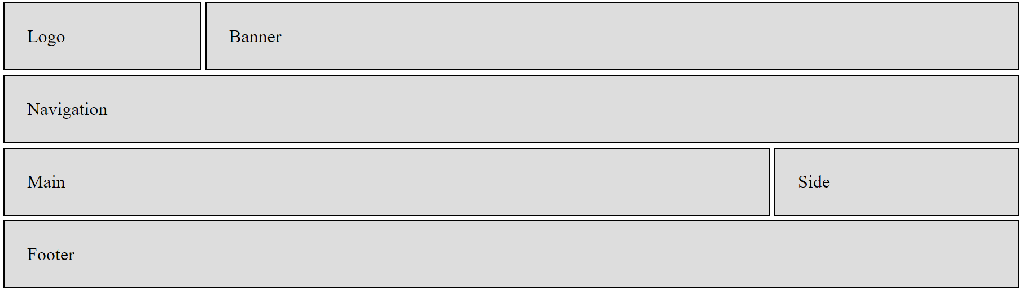

In my container I added a grid gap of 4px and made a section of styling too. I added in my stylesheet that for the box divs a solid border of 1px and black, 20px padding and the background is grey. The I added grid areas for each of my box divs. I then validated my CSS.

**Validation for Grid Area CSS**

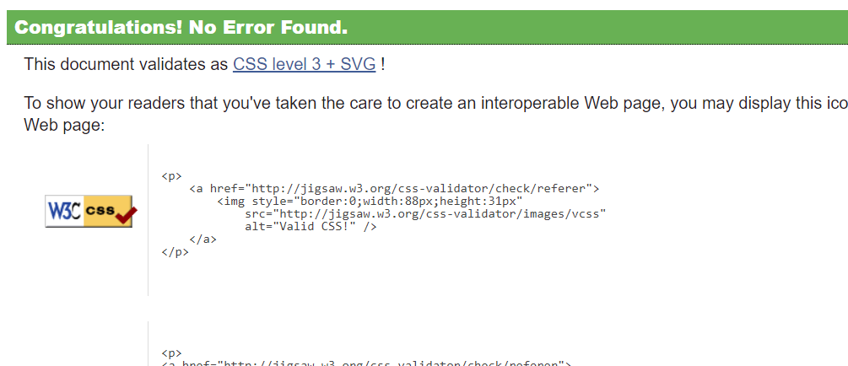

**Colour and the Developer Console**

**Colour Part 1**

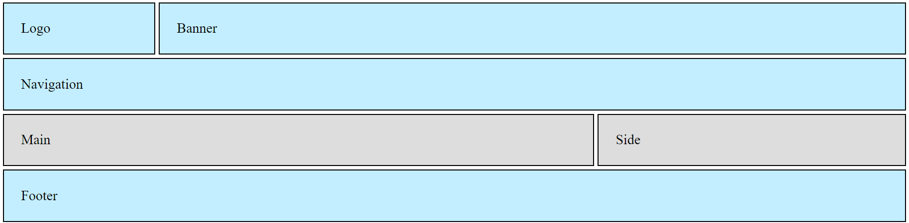

I added in my stylesheet, that the logo, banner, navigation and footer will be the same and that they will have same background colour of light blue. I then experimented in my Developer console the different colours.

**Colour Part 2**

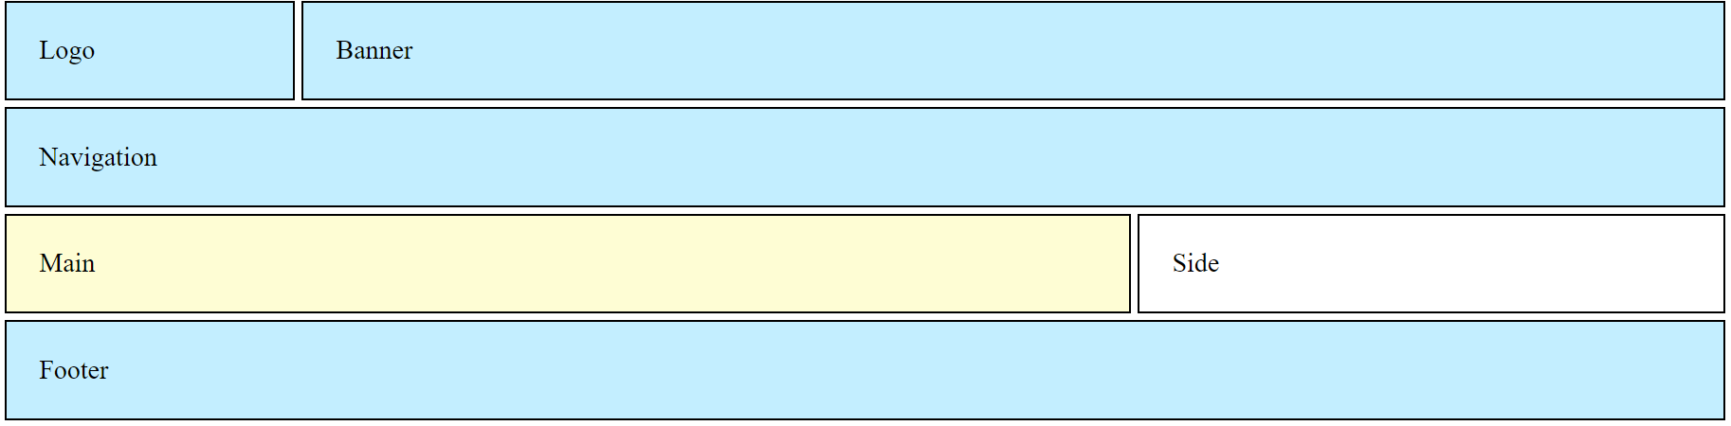

I added the rest of my colours for my main ands side. I thought that using a light colour didn’t work well so I didn’t make any changes to the font colour in my stylesheet.

**Validation of Colours CSS**

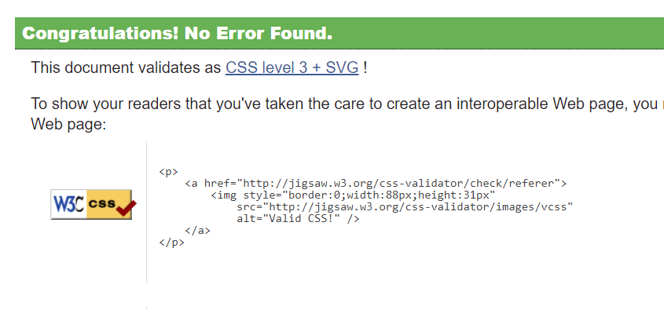

**Google Fonts**

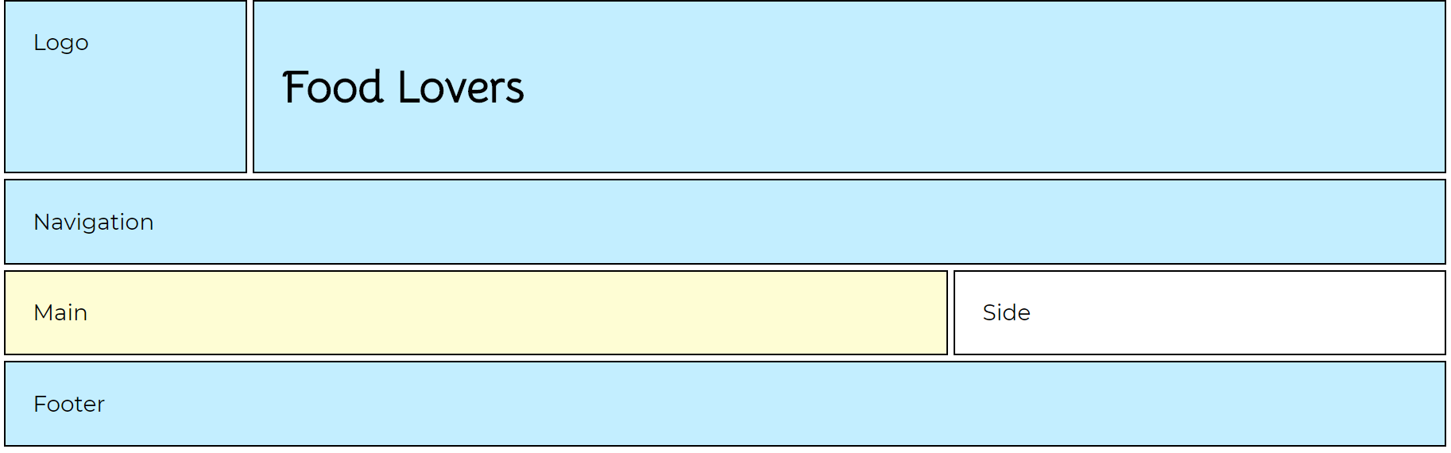

I went into Google Fonts and selected the Bellota and Montserrat fonts. I then copy and pasted the link to these fonts and placed the Bellota font under headings 1,2,3 and 4 as well as setting the Monserrat font under my body. Replacing the Banner text under my banner div with the 1st heading, I previewed and validated both the HTML and CSS.

**Validation of Google Fonts**

|  |  |
| --- | --- |
| HTML | CSS |
|  |  |

**Navigation Links**

|  |  |
| --- | --- |
| Before: from light text... | After: to dark blue hover |
|  |  |

**Final Refined Image**

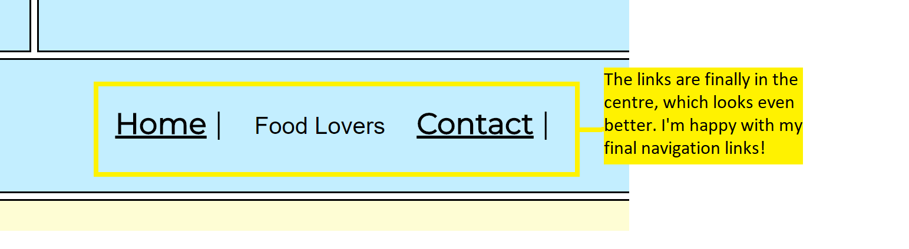

I added the code for the drop-down menu and button on w3schools.com, but adjusted the main text and background colours, as well as the anchoring the links, colours for hover and visited for the rest of my navigation bar. I then took a video of hovering over the button and screenshotted it. However, I thought that the white font didn't look suitable as it’s too light and, I forgot about the rest of the links, as shown in the ‘before’. I decided to refine my link colours by bringing the hover links to dark blue in the ‘after’ section’ which I thought looked much better to read. In the Final refined image, I decided to align my text to the centre to make it even better. I then did a final validation of the HTML and CSS.

**Validation for Navigation Links**

|  |  |
| --- | --- |
| **HTML** | **CSS** |
|  |  |

**Main Page**

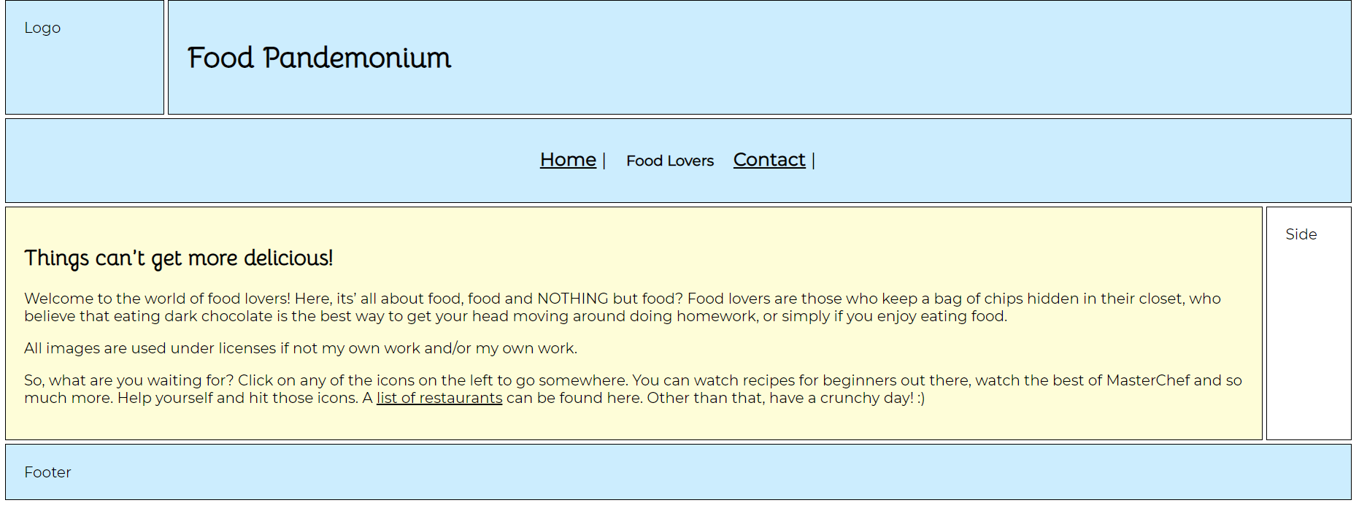

I decide I would do the icons later and put my content first

**Side bar**

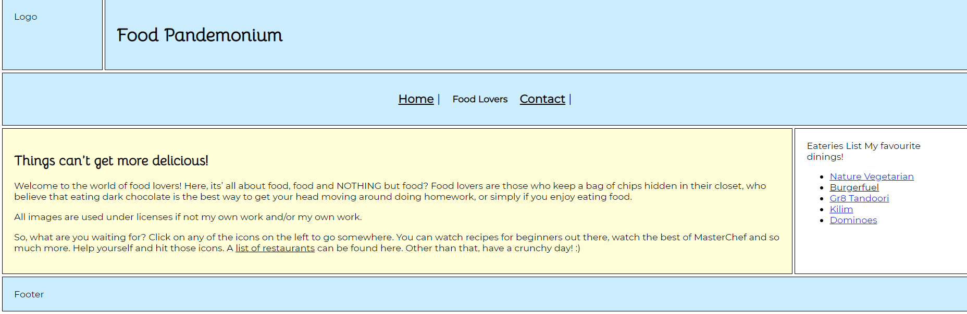

I added a list of my favourite eatiers in the sidebar.

**Rounded Corners**

|  |  |
| --- | --- |
| Before | After |
|  |  |

**Validation for Rounded Corners**

|  |  |
| --- | --- |
| HTML | CSS |
|  |  |

**Footer**

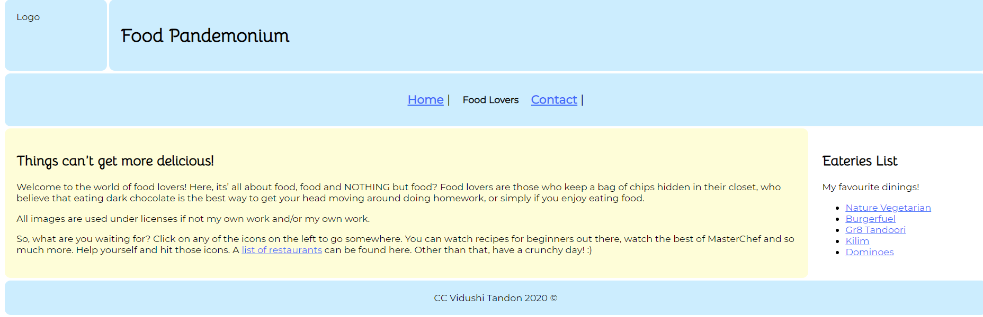

I added my copyright name in the footer and aligned it to the centre. I copy pasted my code from the top to the end of navigation and created/named my food and contact pages. I then validated my HTML and CSS for the home page.

**Validation of Footer**

|  |  |
| --- | --- |
| HTML | CSS |
|  |  |

**Logo**

|  |  |  |
| --- | --- | --- |
| Before: overlapping | After: no overlapping | Final: fading |
|  |  |  |

**Contact Page**

|  |  |
| --- | --- |
| Before ‘Fail” (Setup) | After ‘Fix’ |
|  |  |

**Sidebar (Contact: Text)**

|  |  |
| --- | --- |
| Before |  |
|  |  |

**Further Refinements during Making of Website**

**Sidebar**

|  |  |
| --- | --- |
| Before | After |
|  |  |

In the sidebar, when I tried adding the link for Burgerfuel, it took a long time to load so I could not anchor that link initially, but then afterwards it loaded.

**Logo**

|  |  |
| --- | --- |
| Before | Final Refined: |
|  |  |

**Links to Images**

<https://commons.wikimedia.org/wiki/File:Hara_Bhara_Kabab.JPG>

<https://pixabay.com/photos/food-re-pastry-cuisine-filo-baked-1759336/>